COMHAIRLE CONTAE CHORCAI 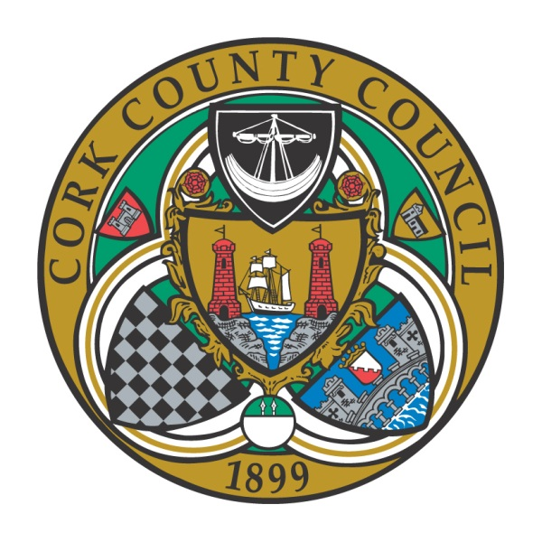 CORK COUNTY COUNCIL

Application Form for taking in charge Public Lighting

General Information

1. Developer’s Name: ________________________________________________

2. Developer’s Address: ________________________________________________

3. Telephone No.___________________ 4. Email Address: ____________

5. Planning Ref. No. ________________________________________________

7. Name of Housing Estate/Road:_________________________________________

8. Address: __________________________________________________________

9. No. of Housing Units: ____________________________________________

10. Energy Supplier: ____________________________________________________

11. A/C Name & No. _________________________________________________

MPRN Information (1st MPRN)

12. (T)MPRN No. _____________________________________________________

13. No. of Lights:________ 14. Lantern Type & Wattage: ____________________

2nd and subsequent MPRN information should be provided where applicable on a separate sheet

The following documents are required to be submitted with the application:

- RECI cert for the lights to be taken in charge, in paper and electronic format.

- Public Lighting Design Report (Lighting Reality) and Public Lighting Layout Drawings, associated with the development.

- As –built drawings of the Housing Estate/Development showing the position of columns (incl. Col. Nos.), micro pillars, ducting Layout, power supply location and circuits from each power source indicating which lights are connected to which supply point.

- Copies of recent energy bill, including evidence that indicates that payments are up to date.

- Details of any warranties (inclusive of expiry dates) associated with component parts.

- Details of each Light in accordance with SEAI/CCMA Standardised Public Lighting Inventory Template excel spreadsheet attached in as much detail as possible.

- General date of installation of Public Lighting (year)

- Circuit drawings and fuse details

Note: Cork County Council will only take over street lights in occupied sections of a housing estates and provided that the lights in question do not constitute part of an MPRN. (i.e. if an MPRN contains some lights within occupied section and some lights in unoccupied section, Cork County Council will not take over any of the lights associated with that MPRN until all of those lights are within a section that is occupied).

Applicants acknowledge that any lights requested for taking-in-charge will be inspected by the Council’s Public Lighting maintenance Contractor in advance and only schemes which are up to standard will be taken in charge. Otherwise the process will revert back until the lights are deemed to have been brought up to standard, by the Applicant.

Signed:________________________ Date:_____________________
Developer

Completed Application Forms for Housing Estates should be returned to:
- Estates Section, Planning Department, Co. Hall, Cork - for North & South Cork Divisions and Estates Section,
- Planning Department, Norton House, Skibbereen – for Western Division.

Completed application forms for new lights/schemes on public roads shall be returned to the Public Lighting Engineer, Cork County Council, Annabella, Mallow, Co. Cork.

This sheet may be used to provide a hand sketch showing the different lights connected to each micropillar.

