Cork County Council Joint Policing Committee (JPC)

28th January 2019

Floor 16, Cork County Council, County Hall, Cork

Present: | Chief Superintendent Tom Myers
Cllr. Frank O Flynn, Chair
Cllr Kevin Conway | Apologies:
Cllr Timmy Collins, Vice Chair | Deputy Sean Sherlock TD
Cllr. Joe Carroll | Ms Nicola Radley, Senior Executive Officer
Cllr. Kay Dawson | In Attendance:
Cllr. Gearóid Murphy | Ms Patricia Liddy,
Cllr. Kevin Murphy | Director of Corporate Services
Cllr. Ronnie Morley | Ms Claire Looney O’Sullivan,
Cllr. Daithi O’Donnabhain | Administrative Officer, Corporate Services
Cllr. Michael Ahern | Ms Majella McMorrow,
Ms Patricia Liddy, Substitute for Chief Executive | Assistant Staff Officer, Corporate Services
Deputy Aindrias Moynihan TD | Mr. Kevin O’Donovan,
Senator Jerry Buttimer | District Supervisor, Social Operations Housing
Mr. Diarmaid Cronin, PPN
Mr. Gavin Falk, PPN
Mr. Tom Howard, PPN
Mr. Sean Kelly, PPN
Mr. John Fuller, PPN
Mr. Liam McCarthy, PPN
Chief Superintendent Con Cadogan
Chief Superintendent Barry McPolin

- Approval of Minutes

Proposed: Councillor Gearóid Murphy

Seconded: Mr Diarmaid Cronin

The Chair welcomed new member Councillor Ronnie Morley.

- Matters Arising

Update on CCTV
Senator Jerry Buttimer informed the meeting that he had spoken to the Minister’s secretary and that a response would issue to the JPC.

- Correspondence
Members noted the following correspondence:
- The Minister for Justice regarding Sulky Racing dated the 24 September 2018
- The Office of public Works regarding Macroom Garda Station dated the 9 October 2018
- The Minister for Transport, Tourism & Sport regarding Speed Limits at Road Works dated the 13 November 2018
- Minister for Justice & Equality regarding Uninsured Drivers dated the 18 January 2019

During the discussion members raised the following points:
- The high cost of insurance is having a serious effect on young people, the cost of a car is approximately half the cost of insurance for many
- Students are commuting as rents are so high
- Smaller insurance claims are not being taken to court and are being settled instead
- In the 1980s the Gun Club set up their own insurance and their fund was in the black within a year
- Since 2016 insurance has fallen 20%, however it is important that companies treat young people fairly
- There is an issue with high awards and cases being settled
- Legal costs are contributing to claims being settled
- Lobbying by Insurance Companies granted by the Oireachtas
- Solicitors have been removed from the process due to the Personal Injuries Board
- Uninsured drivers are driving up premiums and insurance companies should be obliged to share their data with the Gardaí
- No guarantees are given regarding lowering insurance premiums

Members agreed to write to the Minister to highlight the effect of high insurance premiums on young people and how smaller insurance claims being settled rather than taken to court contribute to higher insurance premiums.

- Garda Statistical Report on Crime in Co. Cork – presentation by Chief Superintendent Con Cadogan

In response to members’ queries the Chief Superintendents outlined the following:
- Public order Offences have reduced and this is due to increased enforcement regarding drunkenness
- An increase in arrests for drunkenness results in decreased assaults
- All road traffic accidents are added to the system and classified
- There were 101 incidents of driving under the influence in December of these 20% were drug driving
- Cannabis and cocaine were the main drug detected
- Gardaí must have a reasonable suspicion that a person is driving under the influence in order to test – a judgement call must be made at the scene
- There is no need for people to be overly fearful of the new legislation
- If a driver involved in a fatal road traffic accident has been drinking then this information is sent to the DPP
- The RSA provide high vis jackets on request
- The Protective Services Unit has encourage increased reporting of sexual assault and rape
- Regarding crime trends there are only 2 to 3 categories where increases have been reported, overall crime is falling
- Crime analysis units assist the Guards with targeting resources
- Operation Thor has been very successful and two gangs have been identified
- People need to lock their cars at night and make sure that houses, sheds etc. are secured.
- Many crimes are opportunistic in nature

Members agreed that arrangements be made to invite speakers from the Cork Vintners Association and The Sexual Violence Clinic to future JPC Meetings

- Issues Arising/Notices of Motion
“That a report be provided detailing the reported traffic accidents on the N22 between Macroom and Ballincollig over the past 15 years.” – Aindrias Moynihan, TD

The following report was provided by Chief Superintendent Con Cadogan

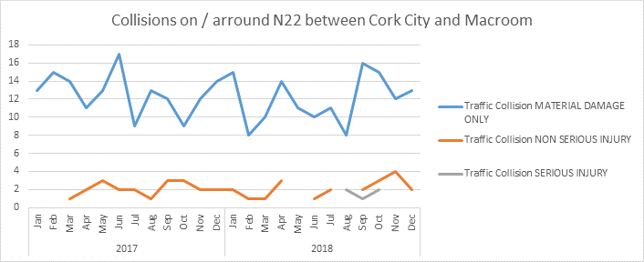

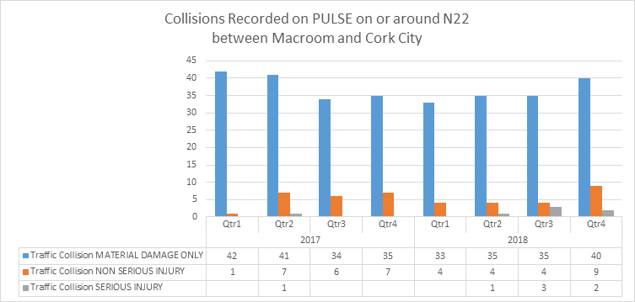

Members agreed to write to the T.I.I regarding the speed limit on the approach to Innishannon Village.

- Draft JPC Communications Policy
Noted by members

- A.O.B

Votes of Sympathy

TO: Chief Superintendent Thomas Myers on the death of his mother, Maureen
TO: Superintendent Mick McGuire on the death of his brother, Terry

This concluded the business of the meeting
Next meeting 13th May 2019

