**Comhairle Contae Chorcaí**

**Cork County Council**

**Halla an Bhaile, Cnoc Naomh Eoin,**

**Cionn tSáile, Co. Chorcaí, Éire.**

**Fón: (021) 4772154 · Faics (021) 4772615**

**Suíomh Gréasáin: www.corkcoco.ie**

**Municipal Hall, St. John’s Hill,**

**Kinsale, Co. Cork, Ireland.**

**Tel: (021) 4772154 · Fax (021) 4772615**

**Web: www.corkcoco.ie**

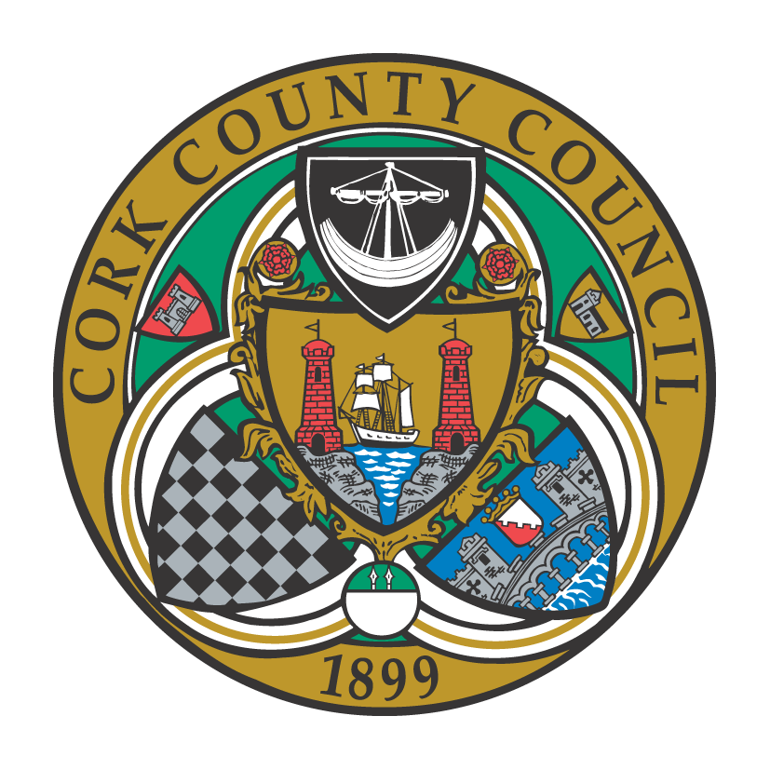

**To the Chairperson and each Member of Bandon-Kinsale Municipal District Area**

Kindly take notice that a meeting of Bandon-Kinsale Municipal District Area will be held on **Thursday 27th May 2021 via Microsoft Teams at 10:00 a**.**m.**

Yours sincerely,

Paul Barry

Municipal District Officer.

**Agenda**

***1. Minutes***

(a) Confirmation of minutes of meeting held on 22nd April 2021.

(b) Matters arising from minutes dated 22nd April 2021.

***2. Reports & Recommendations.***

1. Bandon Library Update – update by Emer O’Brien, County Librarian.
2. Bandon Main Drainage Scheme



1. Engineer’s report
2. Chairperson report
3. Municipal Officer report

***3. Statutory Business***

1. Section 183: Disposal of land at Brownsmills, Kinsale, Co. Cork to Mary Healy Mahalingam for consideration of €30,000.



1. Section 38: Kilbrogan Street, Bandon – Two no. raised table pedestrian crossing points and footpath improvements.



1. Section 38: North Main Street, Bandon



**d) Notice of Motion**

**Cllr. Gillian Coughlan**

Bandon Kinsale Municipal District requests that double yellow lines would be painted and bollard erected at the entrance to the houses at Dromderrig, Kinsale. This is to facilitate safe entry and egress for the residents on the R606.

Bandon Kinsale Municipal District requests that the junction of Chapel Street and the N71 in Bandon would be re-lined and that site-lines and the design of the pedestrian crossing reviewed.

***4. Correspondence***

***5. Any Other Business***