**Comhairle Contae Chorcaí**

**Cork County Council**

**Halla an Bhaile, Cnoc Naomh Eoin,**

**Cionn tSáile, Co. Chorcaí, Éire.**

**Fón: (021) 4772154 · Faics (021) 4772615**

**Suíomh Gréasáin: www.corkcoco.ie**

**Municipal Hall, St. John’s Hill,**

**Kinsale, Co. Cork, Ireland.**

**Tel: (021) 4772154 · Fax (021) 4772615**

**Web: www.corkcoco.ie**

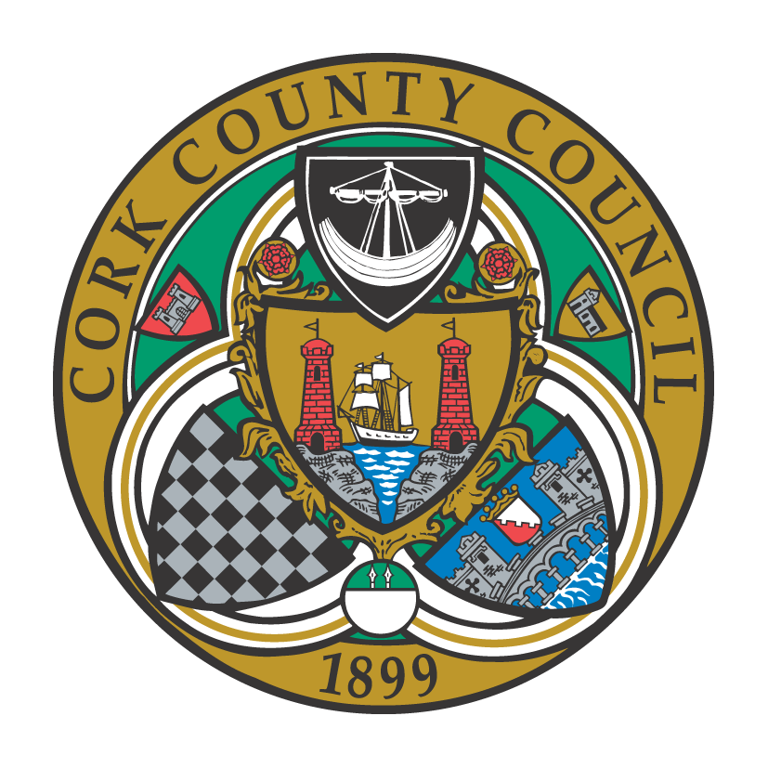

**To the Chairperson and each Member of Bandon-Kinsale Municipal District Area**

Kindly take notice that a meeting of Bandon-Kinsale Municipal District Area will be held on **Thursday 25th November 2021 via Microsoft Teams at 10:00 a**.**m.**

Yours sincerely,

Paul Barry

Municipal District Officer.

**Agenda**

***1. Minutes***

1. Confirmation of minutes of meeting held on 28th October 2021.
2. Matters arising from minutes dated 28th October 2021.

***2. Reports & Recommendations.***

1. Bandon Main Drainage Scheme
2. Engineer’s report
3. Municipal Officer report

***3. Statutory Business***

1. Section 183 of the Local Government Act, 2001, Disposal of site at Cloughmacsimon, Bandon to Mr. Gerard Collins.
2. Notice of Motion submitted by Cllr. Sean O’Donovan

*“That this meeting calls for the protection and purchase by Cork County Council of the woodland currently on the market by Coillte at Riverstick in the Bandon Kinsale MD district. These woodlands have been a huge benefit to the people living in the area, especially during Covid-19 pandemic. It’s important to protect any woodland and green space we have for our people to relax and enjoy a bit of freedom. I call on Cork County Council to act immediately to save this woodland for the people”.*

***4. Correspondence***

None

***5. Any Other Business***