**Comhairle Contae Chorcaí**

**Cork County Council**

**Halla an Bhaile, Cnoc Naomh Eoin,**

**Cionn tSáile, Co. Chorcaí, Éire.**

**Fón: (021) 4772154 · Faics (021) 4772615**

**Suíomh Gréasáin: www.corkcoco.ie**

**Municipal Hall, St. John’s Hill,**

**Kinsale, Co. Cork, Ireland.**

**Tel: (021) 4772154 · Fax (021) 4772615**

**Web: www.corkcoco.ie**

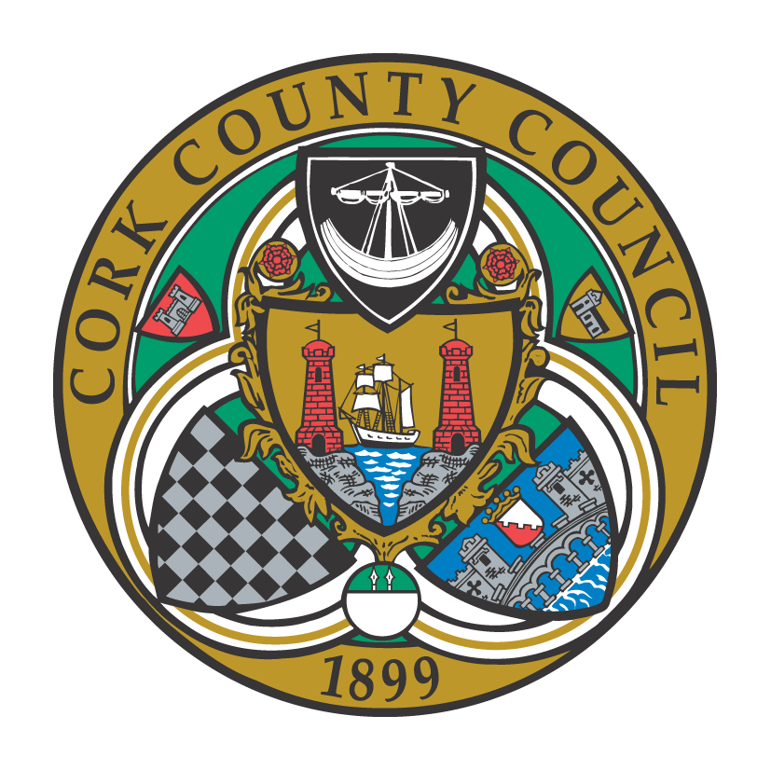

**To the Chairperson and each Member of Bandon-Kinsale Municipal District Area**

Kindly take notice that the Statutory Monthly Meeting of Bandon-Kinsale Municipal District Area will be held on **Thursday 28th May 2020 in upstairs hall of Municipal Hall, Kinsale at 11:30 a**.**m.**

**The meeting will be preceded by an in-committee meeting regarding Grants 2020 at 11.00 a.m.**

Yours sincerely,

Enda O’Halloran,

Municipal District Officer.

**AGENDA**

1. **(a) Confirmation of Minutes of meeting held on 8th May 2020.**

**(b) Matters arising from the Minutes of 8th May 2020.**

1. **Reports and Recommendations**
   1. Engineers Report
   2. MDO Report
   3. Bandon Main Drainage Scheme
   4. Bandon Flood Relief Scheme

**3) Statutory Business**

**4) Pay Parking (Temporary measures)**

**5) Correspondence**