**Comhairle Contae Chorcaí**

**Cork County Council**

**Halla an Bhaile, Cnoc Naomh Eoin,**

**Cionn tSáile, Co. Chorcaí, Éire.**

**Fón: (021) 4772154 · Faics (021) 4772615**

**Suíomh Gréasáin: www.corkcoco.ie**

**Municipal Hall, St. John’s Hill,**

**Kinsale, Co. Cork, Ireland.**

**Tel: (021) 4772154 · Fax (021) 4772615**

**Web: www.corkcoco.ie**

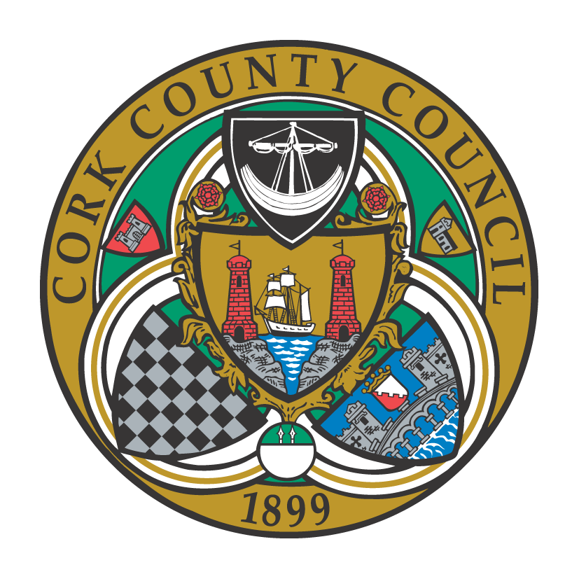

**To the Chairperson and each Member of Bandon-Kinsale Municipal District Area**

Kindly take notice that a meeting of Bandon-Kinsale Municipal District Area will be held on **Thursday 24th March 2022 via Microsoft Teams at 10:00 a**.**m.**

Yours sincerely,

Paul Barry

Municipal District Officer.

**Agenda**

***1. Minutes***

1. Confirmation of minutes of meeting held on 24th February 2022.

(b) Matters arising from minutes dated 24th February 2022.

***2. Reports & Recommendations.***

1. Engineer’s report
2. Municipal Officer report

***3. Statutory Business***

Section 183: that in accordance with the provisions of Section 183 of the Local Government Act, 2001 the proposed disposal of property No 47, Deerpark, Bandon,

Co. Cork. Area: 0.0764 hectares , To Deerpark Community Childcare Service Limited by Guarantee. For 5 years (by way of lease) and €10 per annum.

***4. Correspondence***

Correspondence from Wexford C.C

***5. Any Other Business.***