**Comhairle Contae Chorcaí**

**Cork County Council**

**Halla an Bhaile, Cnoc Naomh Eoin,**

**Cionn tSáile, Co. Chorcaí, Éire.**

**Fón: (021) 4772154 · Faics (021) 4772615**

**Suíomh Gréasáin: www.corkcoco.ie**

**Municipal Hall, St. John’s Hill,**

**Kinsale, Co. Cork, Ireland.**

**Tel: (021) 4772154 · Fax (021) 4772615**

**Web: www.corkcoco.ie**

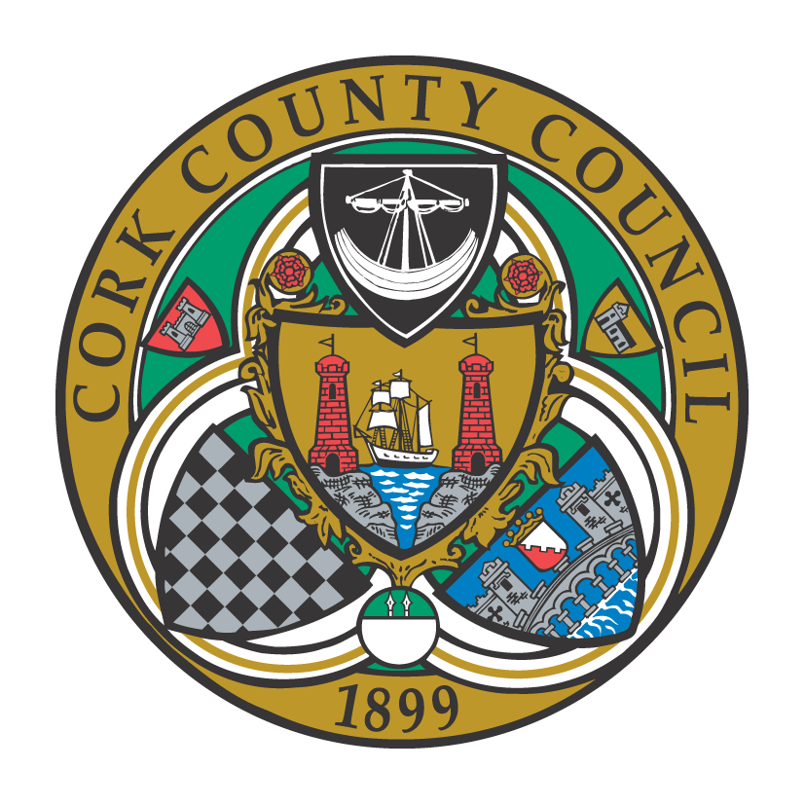

**To the Chairperson and each Member of Bandon-Kinsale Municipal District Area**

Kindly take notice that a meeting of Bandon-Kinsale Municipal District Area will be held on Friday 23rd November 2018 at Town Hall, Kinsale at **10:30 a.m.**

Meeting will be preceded by an “in committee” meeting with representatives from Cork County Council’s Planning Department at **9.30 a.m.**

Yours sincerely,

Enda O’Halloran,

A/Municipal District Officer.

**Agenda for Ordinary Meeting**

***1. Minutes***

1. Confirmation of minutes of Municipal District of Bandon-Kinsale Meeting held in County Hall on 31st October 2018
2. Matters arising from Minutes dated 31st October 2018

***2. Reports & Recommendations.***

1. Bandon Main Drainage Scheme
2. Bandon Flood Relief Scheme
3. Update on Road Works
4. Chairman’s report
5. Municipal District Officers report
6. Housing Report.

***3. Statutory Business***

1. Section 183 of Local Government Act 2001, proposed disposal of land at Ivywood, Myrtleville to Avril & Siobhan Murray.
2. “That Cork County Council would establish a policy of retrofitting/improving vehicular parking in older estates, with the primary focus on disabled parking and access for emergency vehicles.

***4. Correspondence:***

***5. Any Other Business.***

* Statue at St. Finbarr’s Place.
* Date for December meeting.