**Comhairle Contae Chorcaí**

**Cork County Council**

**Halla an Bhaile, Cnoc Naomh Eoin,**

**Cionn tSáile, Co. Chorcaí, Éire.**

**Fón: (021) 4772154 · Faics (021) 4772615**

**Suíomh Gréasáin: www.corkcoco.ie**

**Municipal Hall, St. John’s Hill,**

**Kinsale, Co. Cork, Ireland.**

**Tel: (021) 4772154 · Fax (021) 4772615**

**Web: www.corkcoco.ie**

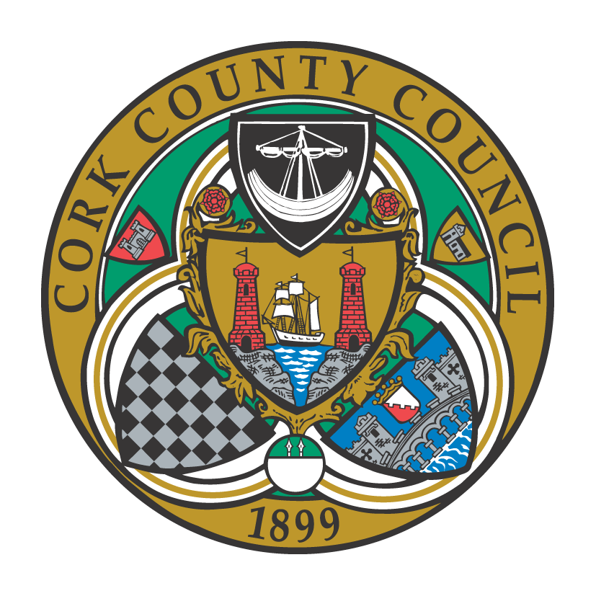

**To the Chairperson and each Member of Bandon-Kinsale Municipal District Area**

Kindly take notice that a meeting of Bandon-Kinsale Municipal District Area will be held on **Thursday 23rd September 2021 via Microsoft Teams at 10:00 a**.**m.**

Yours sincerely,

Paul Barry

Municipal District Officer.

**Agenda**

***1. Minutes***

1. Confirmation of minutes of meeting held on 23rd July 2021.

(b) Matters arising from minutes dated 23rd July 2021.

***2. Reports & Recommendations.***

1. Bandon Main Drainage Scheme
2. Engineer’s report
3. Chairperson report
4. Municipal Officer report

***3. Statutory Business***

1. Section 183 of the Local Government Act, 2001 – Disposal of former pumphouse site at Curragh Hill, Co. Cork to Maurice Kelleher, Curragh Hill, Riverstick, Co. Cork.
2. Notice of Motion submitted by Cllr. Kevin Murphy

*“I proposed several months ago under AOB to investigate a dangerous wall in the Orchards estate and I now ask to make available to this meeting and I also asked re: the taking in charge of the same estate as demanded by the residents.”*

1. Notice of Motion submitted by Cllr. Kevin Murphy

*“That a full report be made available to this meeting on the proposed improvements to the Lower Road (Scilly Walk) which would include hedges, surface, seating, danger spots, etc. to return it to it’s former glory.”*

***4. Correspondence***

***5. Any Other Business***