**Comhairle Contae Chorcaí**

**Cork County Council**

**Halla an Bhaile, Cnoc Naomh Eoin,**

**Cionn tSáile, Co. Chorcaí, Éire.**

**Fón: (021) 4772154 · Faics (021) 4772615**

**Suíomh Gréasáin: www.corkcoco.ie**

**Municipal Hall, St. John’s Hill,**

**Kinsale, Co. Cork, Ireland.**

**Tel: (021) 4772154 · Fax (021) 4772615**

**Web: www.corkcoco.ie**

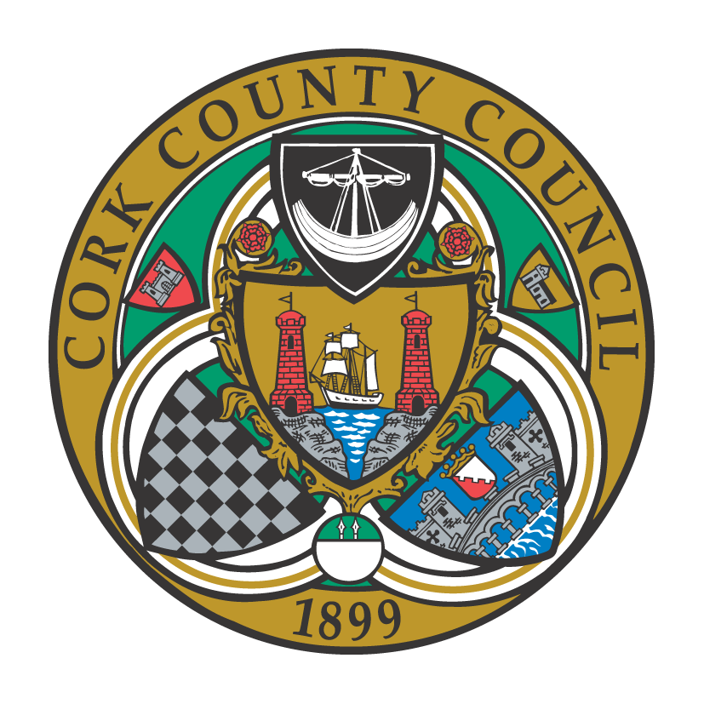

**To the Chairperson and each Member of Bandon-Kinsale Municipal District Area**

Kindly take notice that a meeting of Bandon-Kinsale Municipal District Area will be held on **Tuesday 27th September 2022 on Microsoft Teams at 10:00 a**.**m.**

Yours sincerely,

Paul Barry

Municipal District Officer.

**Agenda**

***1. Minutes***

1. Confirmation of minutes of meeting held on 26th July 2022.

(b) Matters arising from minutes dated 26th July 2022.

***2. Reports & Recommendations.***

1. Update on Bandon Wayfinding Signage.
2. Section 38 Active Travel improvement for Belgooly village
3. Engineer’s report
4. Municipal Officer report

***3. Statutory Business***

Notices of Motion from Cllr. G Coughlan

1) In recognition of our geographical status as an island nation and cognisant of the numerous lives lost due to drowning over the years, that Bandon Kinsale MD invites Swim Ireland to brief members on the possibility of hosting a pop up pool in Bandon so that swimming lessons would become available to as many members of our community as possible. Further to this, that Bandon Kinsale MD fully endorses the concept of hosting a pop up pool in Bandon.’

***4. Correspondence***



***5. Any Other Business.***