**Comhairle Contae Chorcaí**

**Cork County Council**

**Halla an Bhaile, Cnoc Naomh Eoin,**

**Cionn tSáile, Co. Chorcaí, Éire.**

**Fón: (021) 4772154 · Faics (021) 4772615**

**Suíomh Gréasáin: www.corkcoco.ie**

**Municipal Hall, St. John’s Hill,**

**Kinsale, Co. Cork, Ireland.**

**Tel: (021) 4772154 · Fax (021) 4772615**

**Web: www.corkcoco.ie**

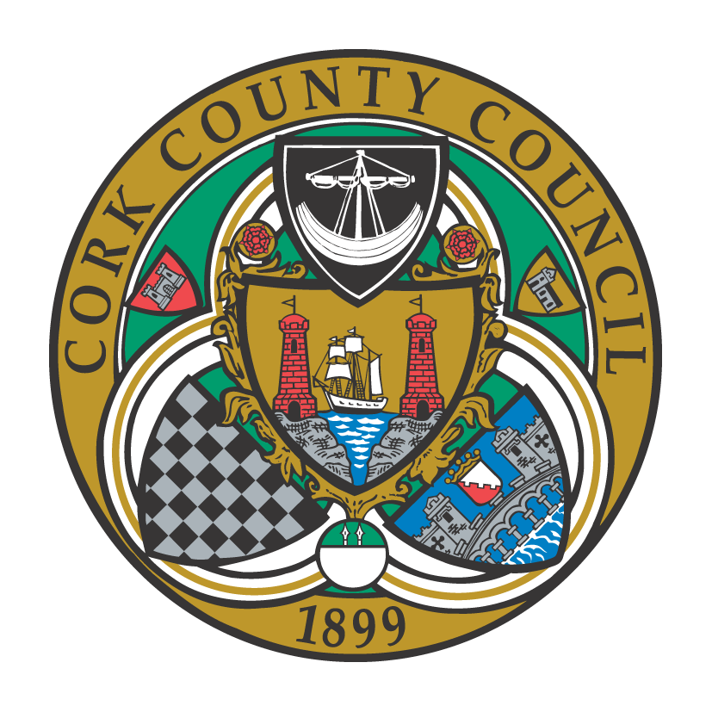

**To the Chairperson and each Member of Bandon-Kinsale Municipal District Area**

Kindly take notice that a meeting of Bandon-Kinsale Municipal District Area will be held on **Tuesday 25th Oct 2022 on Microsoft Teams at 10:00 a**.**m.**

Yours sincerely,

Paul Barry

Municipal District Officer.

**Agenda**

***1. Minutes***

1. Confirmation of minutes of meeting held on 27th Sept 2022.

(b) Matters arising from minutes dated 27th Sept 2022

***2. Reports & Recommendations.***

1. Engineer’s report
2. Municipal Officer report

***3. Statutory Business***

1)Section 183 Disposal of land at rear of 1 St. Bridget’s Terrace, Bandon,

Co.Cork to Mr. Florian Necula for the sum of €1000

***4. Correspondence***

***5. Any Other Business.***