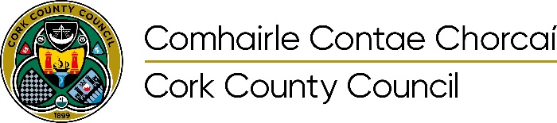

Licensed mobile coffee unit at Mallow Castle Grounds Application Form
Incomplete applications will be disqualified
All Applications must be received by 4pm 28th April 2023

PLEASE READ THE POLICY DOCUMENT BEFORE COMPLETING THIS FORM
• Please ensure that each section of this application form is fully completed and signed, and that all
necessary documentation is attached. Failure to complete this form correctly or accurately or attach the necessary documentation will invalidate your application and it will be returned.
• Do not include any payment with your application.
• Applications which do not meet Cork County Council’s selection criteria will be refused. Cork County Council’s selection of applications will be based on a number of criteria, including but not limited to experience, quality, product type, overall suitability, waste management plan.
• Please ensure you supply photographs and details of your unit/stall dimensions

SECTION 1: Trader Details
Name of Applicant:
Address:
Mobile Number:
Email:
Date of Birth:
Trading Name:
PPS No/Tax Reference No:
Tax Clearance Certificate/ TCAN No:
The Company name:
Registration Number, as supplied by the Companies Registration Office:

SECTION 2: Trading History

Number of years trading: ______

List where you have traded and dates of same (include details on an extra page if required):
Trading Area/Market | Dates of Trading

Are you a member of any trade associations/organisations eg Good Food Ireland, Craft Council of Ireland: ____________________________________________________________________________________________________________________________________________________________________Dimensions of your unit/stall: ____________________________________________________________________________________________________________________________________________________________________ __________________________________________________________________________________Please list types of packaging used (eg compostable, recycled): ______________________________________________________________________________________________________________________________________________________________________________________________________________________________________________

SECTION 3: Insurance Details
Traders are required to hold insurance cover to the following limits. Please confirm that the following insurances will be put in place if your application is successful.
Public Liability €6.5 million: YES NO
Employers Liability €13 million: YES NO
Copy of public liability insurance policy of at least €6.5 million, in the case of any one accident, with specific indemnity to Cork County Council on the policy will be required to be submitted if an offer of is made.
Please include the following with your application.
• 2 passport photographs of the Licence Holder
• Proof of identity (Passport/drivers licence) for the Licence Holder
• Copy of HSE registration
• Photographs of the unit to be used
• Waste Management Plan, outlining procedure for receptacle waste segregated system
(general/recyclable/food waste)
The following procedure is in place:
1. Completed Application form is submitted.
2. Assessment
3. Successful Applicants will be issued letter, invoice and request for insurances.
4. On receipt of payment of €600 annual fee and insurances, licence for designated area will be issued.

DECLARATION
I DECLARE ---
1. that the foregoing particulars submitted are correct
2. That I have read Cork County Council’s Policy document for Licence for Mobile Coffee unit and note the provisions contained therein.
Name Printed
Signature
Date:

