___________________________________________________________
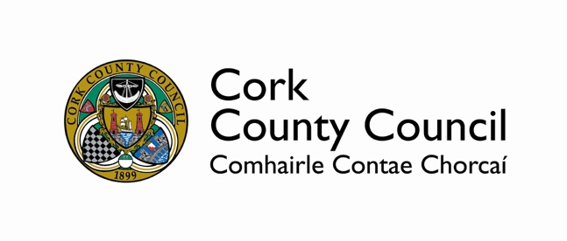

COUNTY CORK COMMEMORATIONS GRANT SCHEME 2020

Guidelines and Criteria
___________________________________________________________

1. Background:

The County of Cork played a most pivotal role in the Anglo-Irish War of Independence and ensuing Civil War. Cork County Council, supported by the Department of Culture, Heritage and the Gaeltacht, is in full recognition of this, and furthermore recognises the appetite that exists within the County, to commemorate the centenary of this defining period of Irish history.

To guide commemorations over the Decade of Centenaries, and in particular the War of Independence and Civil War, the State’s Expert Advisory Group on Centenary Commemorations has published a document titled the ‘Decade of Centenaries Second Phase Guidance 2018–2023’. This document provides advice on ‘how the challenging events of this important and formative period in our history and related themes, might be meaningfully, proportionately and sensitively remembered’ and is underpinned by important core principles:

• The aim of commemoration should be to broaden sympathies without having to abandon loyalties, noting that while there is a common history, there is not necessarily a common memory
• In commemorating, it is important not to forget the bloodshed and the deep antagonisms of these years and how such events still remain a very real part of the consciousness of local communities
• Commemorations should be inclusive and not ignore differences and divisions.

Many of the events of this period in Irish history have great local significance. The purpose of the County Cork Commemorative Grant Scheme 2020 is to support local groups, organisations and individuals who wish to ensure the appropriate commemoration of significant local events, both by way of ceremonial events, but also with regard to any range of projects (from school projects and the arts, to documentaries and exhibitions).

Any and all projects proposed under the County Cork Commemorative Grant Scheme 2020, must fall under the main principles of the ‘Decade of Centenaries Second Phase Guidance 2018–2023’ and advice on the various types of projects that will in principle be supported by the Fund, as well as the particulars of same, is set out hereunder.

Note, that for the purposes of the Fund, and the effectiveness of same in covering a whole range of different undertakings, applicants will be requested to indicate under which category their proposal falls under (said categories correlating with those established for the commemoration of the centenary of the Easter Rising in 2016):

1: Ceremonial Event: A local commemorative event to mark a key local occurrence (i.e. ambush, attack, fatalities, etc.)

2: Historical Reflection (The Past presenting the Future): An exploration of how the period has impacted on us today, and how today, we can re-imagine the Ireland that was envisaged one hundred years ago

3: Community Participation/Pride in Community: Undertakings that encourage widespread community involvement. Creativity in approach is most welcome.

4: The Irish Language: Proposals that look at the importance of the Irish Language and Irish culture.

5: Youth and Imagination: Proposals that engage positively with young people to develop their understanding of the period being remembered and the role of their locality in same

6: Cultural Expression: The expression of this period through any number of creative outputs

7: Global and Diaspora: Reaching out to the Cork Diaspora around the world to ensure that all Irish people, and indeed those abroad with an interest in Irish Culture and History, can avail of the opportunity to remember this period.

Applicants can submit their proposals in relation to any of these categories.

2. Criteria for Funding

Minimum Eligibility Requirements:

Under this Grant Scheme each application must meet certain criterion, prior to proceeding to the final assessment process. Proposals with a community focus will be given priority. It is important to note that there are limits to the amount of funding available and not all applications may be successful.

To be eligible for funding the following must be demonstrated:

- That the proposal is to take place within or relate to the functional area of Cork County Council or promotes the role of County Cork to audiences further afield
- That the proposal has been organised at community level and will either encourage or benefit participation in the centenary commemorations of 1920-1923
- That the proposal meets with the key principles of the ‘Decade of Centenaries Second Phase Guidance 2018–2023’ and at least one of the seven strands outlined above
- That the project will be accessible to diverse audiences and participants and will be inclusive in theme and approach.
- That the proposal will enhance the knowledge of the history of the War of Independence and Civil War in a local area / community.
- That the proposal will be designed on a realistic financial basis providing good value for money with all funding used effectively and only in accordance with the objectives of the event/project.
- That the proposal will make a positive contribution to the programme of Commemorative Events and Projects in the County of Cork, governing the Centenary commemorations of the War of Independence and Civil War
- That each applicant has in place (or will have in place subject to a successful application) adequate Insurance cover for all activities, as appropriate;
- That the proposed project/event will be completed and the request for drawdown of grant submitted to Cork County Council’s Commemorations Office, by Friday 23rd October, 2020, unless otherwise agreed.

While the purpose of the County Cork Commemoration Grant Scheme 2020 is for the support of commemorations relating to the year 1920; events and projects relating to occurrences in 1921, 1922 and 1923 will also be considered under the scheme, where practicable and feasible to do so, in the understanding that many centenary dates warrant longer lead-in times.

In addition to the above, the following details must also be conveyed:

- The anticipated target audience, where relevant
- A breakdown of costs for undertaking the proposed project
- Any additional supports and funding that may be required and have been secured from relevant stakeholders

All grant recipients will be required to submit a summary report of the project/event/initiative funded and will furthermore be required to clearly show that they have acknowledged the association of the event /initiative with the Decade of Centenaries Programme 2012-2023 and the support of Cork County Council through the use of social media, logos, branding, etc. Full details of all requirements will be set out in the letter of offer for successful applicants and will also include details of attendance and participation; a break-down of expenditure, and the provision of three high quality photographs and or film footage that can be used by Cork County Council and/or the Department of Culture, Heritage and the Gaeltacht. Positive consideration, in principle, will be given to proposals that include the capturing of the event/project in question by video.

3. Particulars of Funding:

It is the purpose of this scheme that each community will have the opportunity to tell their story and look at elements of their community’s involvement in the War of Independence and/or Civil War that deserves special mention. Projects that connect with each of the seven Strands mentioned in this document will be encouraged, i.e. those that are creative and inclusive in approach, reflecting history and cultural expression, commemoration and remembrance/reflection – projects and events that reach out to and involve all generations and all of the community, both at home and abroad.

The following headings now highlight the main particulars of this funding scheme:

How much funding will be awarded per successful application?

Fund amounts granted will not exceed €7,500 for any individual project and it is envisaged that the majority of applications will be for events and projects that range in cost from a few hundred euro to a few thousand.

How will the Decision on funding be made?

Decisions will be taken on a number of grounds, including the following selection criteria:

- The extent to which the proposed event/project correlates with a key occurrence/figure regarding County Cork and the War of Independence and/or Civil War
- The extent to which the proposal meets with the principles of the ‘Decade of Centenaries Second Phase Guidance 2018–2023’ and any one (or many) of the seven strands particular to this funding scheme (Ceremonial; Historical Reflection, Community Participation, The Irish Language, Youth and Imagination, Cultural Expression and Global/Diaspora).
- The extent to which the proposed event/project maximises community/citizen engagement as well as inclusivity and diversity in approach
- The cost of the proposed event/project and its feasibility, where any additional supports and funding requirements are identified and confirmed

Please note there is no guarantee of funding for projects/events that nonetheless may have achieved the minimum criteria. The fund is limited and eligible applications will be evaluated on a competitive basis, including amongst other factors, the selection criteria outlined above. Also of note is that there are eight Municipal Districts in County Cork and geographical representation and distribution of funds will play a part in the overall awarding of grants.

What items and expenses are excluded from the Scheme?
- Spend on alcoholic beverages, fines, penalty payments, legal cost, audit fees, insurance costs, financial consultancy fees and wages and salaries of consultants
- Any proposal where it is determined that the main beneficiary would be a private entity
- Accommodation costs
- In general, the cost of items for resale are ineligible
- Projects that do not relate to the commemoration of the War of Independence/Civil War

What typical projects/events are included in the Scheme?
- Ceremonial Events and Community Gatherings
- Memorial Plaques and Sculptures
- Gardens of Remembrance
- Art and Drama
- Heritage Projects
- Community related Genealogy and Oral History Projects tracing back to the period
- Projects relating to the Irish language, traditional Irish music, and the two Gaeltachts of Oileán Chléire and Múscraí
- Lectures, summer schools, and field trips/re-enactments
- Publications
- A project/event that correlates with the 1920-1923 timeline and the key Cork concepts/people of the period (see Appendix 1 and the heritage upcoming events section of www.corkcoco.ie/arts-heritage for further information)
- Other – if a case can be made that it will form an appropriate component of commemoration and that it is in keeping with at least one of the seven main strands and key principles of the Decade of Centenaries Second Phase Guidance 2018–2023’

Please note: when organising a date(s) for any event(s), it is important be cognisant of the numerous events already scheduled throughout the year and arrange, in so far as is possible, for the proposed event not to clash. The most up-to-date calendar of centenary themed events for County Cork for the 2020-2023 is available to view on the events section of Cork County Council’s Heritage Website, www.corkcoco.ie/arts-heritage.

If successful how is the Fund to be drawn down?

Payment will only be made after the event or project is completed, save the following exception: {given the nature of some events advance funding may be necessary and Cork County Council will decide on this matter on a case by case basis}. In order to receive full payment, the successful applicant must provide the following:

- Evidence that the event or project has taken place. This must include a signed disclaimer and the provision of at least three high quality photographs and/or videographic evidence that can be used by Cork County Council and/or the Department of Culture, Heritage and the Gaeltacht.
- Receipts/Invoices for all items that exceed 10% of overall cost and a full breakdown of all costs incurred.
- A summary report (the letter of offer will set out the specific requirements, which will include details of attendance and participation; expenditure breakdown, promotion of the project/initiative, etc.).

Photographs and where possible video of the project/event will be required as part of the summary report, which may be used by Cork County Council on print or digital platforms in promotions associated with the fund

Cork County Council reserves the right to audit the records pertaining to any event or project in order to ensure compliance with the Cork County Council guidelines.

Unless otherwise agreed, funding not claimed by the agreed deadline will be cancelled.

The deadline date is Friday, October 23rd 2020.

Terms of Funding:

Outcome on evaluation of applications:
Successful applicants will receive a Letter of offer by email in April/early May 2020. This letter will form the contract between Cork County Council and the organiser and will detail all conditions and requirements. A list of successful applicants will be published on Cork County Council’s website stating the name, date and details of the event/project taking place. Upon request, unsuccessful applicants will also be informed as to why their application was unsuccessful.

Promotion:
Successful applicants must acknowledge the association of their event /initiative with the Decade of Centenaries Programme 2012-2023 and Cork County Council in all promotional activities and digital communications. The Cork County Council logo must be used in a prominent place on all materials produced in relation to the project. Where Social Media platforms are engaged prior, during or after the event, Cork County Council should be tagged and referenced as the event sponsor.

Upon confirmation of all successful applications, you must ensure that your project is promoted as part of the Commemorative Programme for County Cork, having been supported by Cork County Council through its Commemorations Committee. The letter of offer will set out the precise logos to be utilised on all publicity, press and marketing material produced in connection with the project / event. With any events being undertaken, consideration should also be made by each organiser with regard to inviting the Mayor of the County of Cork, local Representatives and the members of Cork County Council’s Commemorations Committee as well as key Cork County Council staff.

In support of the upcoming commemorations, Cork County Council will act as a vector in promoting a myriad of related local events and projects throughout the County. These will include events that were successful in the 2020 Grant Scheme as well as related and relevant projects where funding was not sought/received. This Programme will be made available online at https://www.corkcoco.ie/arts-heritage and successful applicants must submit all details of events taking place for inclusion and promotion online (same to be done by emailing commemorations@corkcoco.ie).

Submission of Proposed Projects:
Details of all proposed projects must be submitted to Cork County Council by Thursday March 26th 2020 to be considered for inclusion in County Cork’s Commemorative Programme 2020-2023. Where funding is being sought for any or all aspects of a project the accompanying application form must be filled out completely and submitted by said same date.

Applications can be made online (www.yourcouncil.ie); sent by post to Commemorations Grant Scheme 2020, C/O Conor Nelligan, Cork County Council, Floor 3, County Hall, Carrigrohane Road, Cork and/or by email to commemorations@corkcoco.ie, to be received prior to 12 noon, Thursday, 26th March, 2020. You may also submit accompanying additional documentation with your application form as appropriate and please note that information supplied is subject to the Freedom of Information Act. If you would like an application ‘as gaeilge’ please send an email to commemorations@corkcoco.ie requesting same.

A note on Data Protection:
Please note that Personal information is collected by Cork County Council in the carrying out of its functions with regard to commemorative activity. Legally the Local Authority can process this information as it has been obtained with your consent and it is necessary in order to comply with requirements. The protection of your personal data is a key priority for the Council and your data will be processed in line with the Council’s Privacy Policy which is available at https://www.corkcoco.ie/privacy-statement-cork-county-council or in hardcopy from any Council office.

Should you have any questions about the Council’s Privacy Policy or the information that Cork County Council hold about you, please contact the Council by email to dpo@corkcoco.ie or write to the Data Protection Officer, Cork County Council, County Hall, Carrigrohane Road, Cork, Ireland.

Child Protection
It is Cork County Council policy that applicants proposing activities involving children must supply an up to date Child Protection Policy. Failure to submit a valid document or submission of a partial document will render the application invalid.

Typing of applications
Applicants are encouraged to type and review their applications. Cork County Council cannot be responsible for any errors or misunderstandings that may arise from illegible or un-reviewed information supplied.

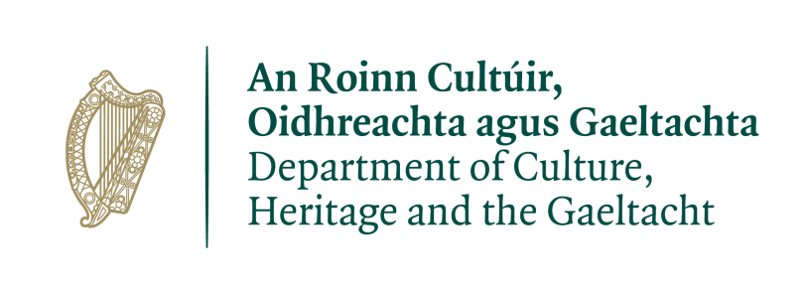
The County Cork Commemorations Grant Scheme is part funded by the Department of Culture, Heritage and the Gaeltacht under the Decade of Centenaries Programme 2012-2023.

___________________________________________________________
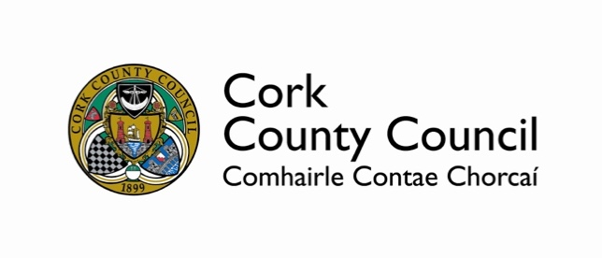

COUNTY CORK COMMEMORATIONS GRANT SCHEME 2020

COUNTY OF CORK APPLICATION FORM
___________________________________________________________

Please read Guidelines and Criteria before submitting application.

CLOSING DATE: 12 noon on Thursday 26 March 2020

- GENERAL:

Applicant/Organisation Name(s): _____________________________________________________________________________ _____________________________________________________________________________

Contact Person: _________________________________________________________________________

Phone no.: ____________________________________________________________________

Email:________________________________________________________________________

Contact Postal Address: _____________________________________________________________________________
_____________________________________________________________________________

- PROJECT/EVENT DETAILS:
Title of proposed project/initiative/event:

A description of the project/initiative/event (circa 200 words) setting out the relevance of same and how it embodies the commemoration of the War of Independence/Civil War at the local level. Please note it is intended that this description will be used online for promotional purposes and all details, including date, venue and time, as applicable, must be as precise as possible:

Location of project / event (i.e. townland; nearest village/town and venue as appropriate)?

_____________________________________________________________________________

Municipal District area in which the applicant/project is based?

____________________________________________________________________________

Precise Date(s) of project / event? Please note that this date(s) will be promoted online -

_____________________________________________________________________________

To which of the following does the Project / Event relate to:

STRAND | NAME | Please tick
1 | State Ceremonial
2 | Historical Reflection
3 | An Teanga Bheo
4 | Youth and Imagination
5 | Cultural Expression
6 | Community Participation
7 | Global and Diaspora

Please state the type of Event / Project from one or more of the following: Ceremonial Events/Community Gatherings, the Arts, lectures, exhibitions,, re-enactments, commemorative gardens, memorials/plaques, publications/other forms of documenting and/or “other”. If “other“ please also state below: -

_____________________________________________________________________________

_____________________________________________________________________________

_____________________________________________________________________________

Please provide details of the target audience and numbers (eg children, families, communities etc) and the location of the project or target area of the project:

- Financial information

Expenditure: It is vital that you provide as much detail about the cost of the proposed project. This will aid our assessment of the feasibility of the project.

Income: It is equally important that each applicant provides details of all projected income sources. Cork County Council will only consider applications that make a valid case for support for any shortfall between income and expenditure.

Please provide a detailed breakdown of costs of this proposal:
ITEM (eg, printing, marketing, services, etc) | ESTIMATED COST (€)
TOTAL ESTIMATED COST

INCOME Please provide a detailed breakdown of all income sources:
ITEM (eg, sponsorship, own resources, other funding sources) | ESTIMATED INCOME (€)
TOTAL ESTIMATED INCOME

Total income: __________________ Total Expenditure:___________________

TOTAL AMOUNT SOUGHT FROM CORK COUNTY COUNCIL:

€_______________

Has this project received or applied for other sources of funding? Yes ____ No ____
If yes, please state the source and amount of funding:

Has this project received or applied for other sources of funding? Yes ____ No ____

- PROMOTION
Please indicate how the project/initiative/event will be promoted, i.e. brochures, posters, radio, facebook, Instagram, twitter, newspaper, etc.:

Please provide details of your experience in delivering projects/initiatives/events of this nature (this to also include the competencies/key skills of the group/individual):

Would you like to be kept informed by email of upcoming heritage events, news and information regarding the commemoration of 1920-1923 in the County of Cork? If yes, please enter the corresponding email address here: _____________________________________________________________________________

3. APPLICANT STATEMENT

I have completed all relevant sections of this application form and confirm that all information provided is accurate.

Name (printed): ________________________ Signature: ________________________

Date: _______________________________________

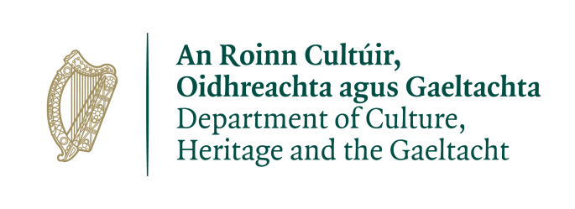
The County Cork Commemorations Grant Scheme is part funded by the Department of Culture, Heritage and the Gaeltacht under the Decade of Centenaries Programme 2012-2023.

APPENDIX 1

SUMMARY OF KEY COUNTY CORK CONCEPTS/PEOPLE REGARDING THE PERIOD 1920-1923

There were many significant events in the County of Cork during the period 1920 – 1923, beginning with what was reported as the first officially sanctioned attack on an RIC Barracks in Carrigtwohill on 03/01/20 to the killing of Liam Lynch on 10/04/23, who although from Limerick, had spent most of his life living in Cork (Fermoy). 1920 saw the assassination of Tomás Mac Curtain from Mourneabbey in North Cork; the death of Terence McSwiney from hunger strike who had represented mid-County Cork as a T.D. in the First Dáil and the very significant Kilmichael Ambush on 28/11/20, which saw 20 deaths. Throughout 1920, close to 100 notable incidents occurred in the County of Cork, also including the Kidnapping in Fermoy of Brigadier-General Cuthbert Lucas (the highest ranking Officer captured during the War of Independence in Ireland) and the capture of Mallow Military Barracks on 28th September, 1920 – the only Military Barracks captured during the War of Independence as well as the death of Michael Fitzgerald (Fermoy) on hunger strike on 17th October 1920, one week prior to the death of Terence McSwiney.

1921 saw the first War of Independence Execution under Martial Law when Con Murphy from Millstreet was killed (01/02/21); the Upton Train Ambush which saw a number of fatalities and the Clonmult Ambush (20/02/21), which was the I.R.A.’s greatest single loss of life during the War. It is estimated that over 700 people lost their lives in the period from 1920-1923 due to the War of Independence and Civil War and community groups from throughout the County have already been engaging with Cork County Council with regard to proposed commemorative projects, events and initiatives. The 2020 County Cork Commemorations Grant Scheme has been established given the great track record of groups in the County and given the success of a similar Scheme in 2016, which resulted in over 500 commemorative events and projects that year in County Cork – the highest anywhere in Ireland.

These past number of months Cork County Council has been busy working on a centenary timeline to span the 1920-1923 period, said listing having more than 500 entries. These include all the key occurrences of 1920 – 1923 including all major events from the County of Cork (including some other locations that involved people from County Cork), as well as key developments on the national level during this timeframe. All key ambushes, attacks and executions are included as well as events that saw the loss of life of Cork people, whether in Cork or further afield. This timeline is available to view on the upcoming heritage events section of www.corkcoco.ie/arts-heritage and at: https://www.corkcoco.ie/sites/default/files/2020-02/centenary-timeline-for-the-county-of-cork-1920-to-1924.pdf

A highly successful undertaking by Cork County Council in 2016 was the making available of a constantly updated Programme of Centenary Events online. Given the wonderful interest shown by groups in County Cork in commemorating the War of Independence and Civil War a programme for 2020-2023 is being developed. Groups are encouraged to submit detail of their own local events and initiatives and these will be promoted far and wide by Cork County Council.

Cork County Council and its Commemorations Committee, through the County Cork Commemoration Grant Scheme 2020, seeks to ensure that County Cork’s participants in the War of Independence and Civil War are remembered and will look forward to the many different proposals submitted.

_ _ _ _ _ _ _ _ _ _ _ _ _ _ _ _ _ _ _ _ _ _ _ _ _ _ _ _ _ _ _ _ _ _ _ _ _ _ _ _ _ _ _ _ _ _ _ _ _ _ _ _

